How To Process Owner 1099’s through Property Genie
FACT: The Income Amount on an owner’s 1099 is calculated through amount of credits received each year by Rent Payments, Additional Rent Payments (aka Late Fees) and Forfeited Security Deposits.
FACT: The Expense Amount on an owner’s 1099 is calculated by the total amount of charges posted to the owner’s property ledger (i.e. Vendor Invoices, Management Fees, etc.)

- Setup your company’s IRS Tax ID in the SYSTEM SETTINGS / COMPANY SETTINGS / Company info tab. (ACH Section).
The Company ID field is the only one necessary to fill in when processing 1099’s. See “How to Process Owner Payments via ACH” to learn more about the rest of the fields used for NACHA file generation.
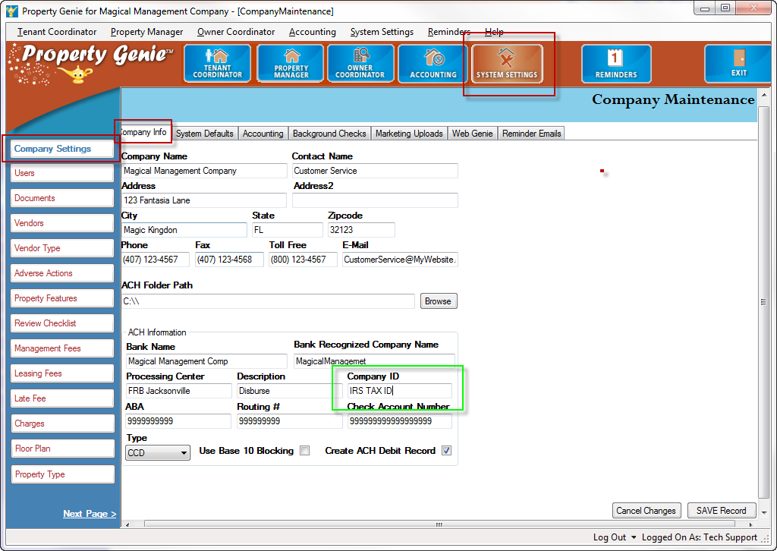

- Make sure that all of your owners that provided an alternate address for their 1099’s have been setup in the Owner’s Record in the Accounting Settings tab.
If the owner of the property does not provide an alternate address for their 1099 Property Genie will use the data stored in the owner’s MAILING ADDRESS.
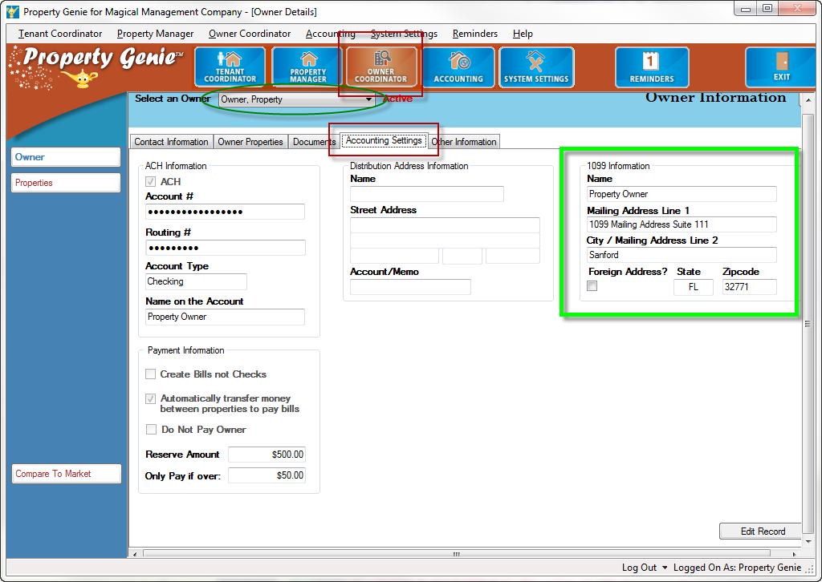

- Generate Year Long Summary Statements for all of your owners.
- Go to the Accounting/Statements/Owner Statements screen
- Uncheck the box labeled “Show Only Active Owners”. (since you want to include owner’s that may have terminated their management agreement within the past 12 months)
- Check the box labeled “Process for Rent Received”. Because we are including all of the owners (Active and Inactive) this filter will only generate a statement for an owner who has received at least one credit via a rent payment.
- Select the Period Format - Summary Statement format.
- Set Start date to 1/1/(Year) - 12/31/(Year)
- Check the “Print” box if you wish to send a copy of the statements to your default printer.
- Click the “Print and Upload” button. (If you do not have PRINT selected the button will be labeled “Upload Only”)
- Confirm the prompt “Are you sure you want to Print and Upload Owner Statements for the period ending on 12/31/(Year)”by clicking the “Yes” button.

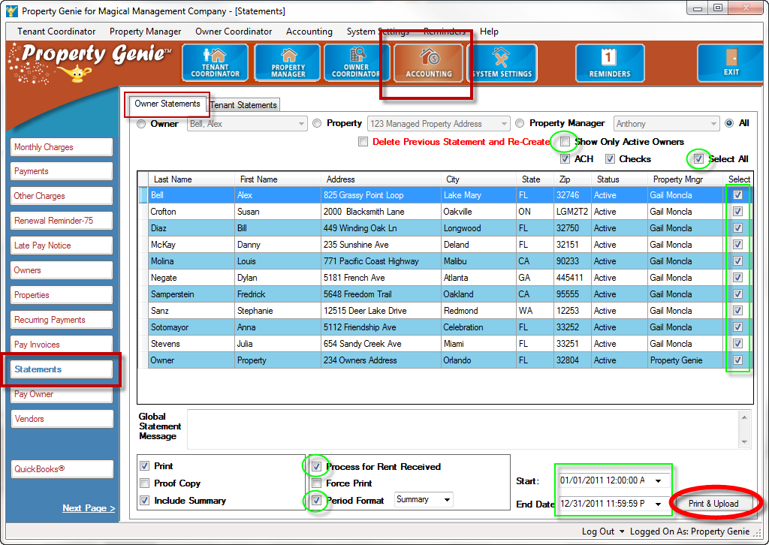

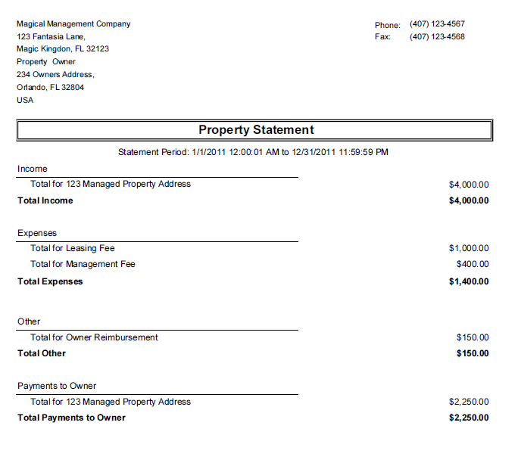
- Load your owner’s 1099 data in the 1099 reports screen.

- Go to the Accounting/Reports/ 1099 screen
- Select the appropriate “Year” from the dropdown list
- In the “See” box, select “Owners” (Property Genie recommends to process your owner and vendor 1099s separately).
- Use the box labeled “Select All” or manually select which owners you wish to process.
*If you choose SELECT ALL you will see the following prompt: “This will clear any previous selection settings. Are you sure you want to Update ALL records?”
**After choosing select all you will get the same prompt if you try to remove someone from your selection. It will ask if you want to “update all records”, if you say yes then everyone will become unselected, if you say NO to the prompt “update all records” then only the record you wish to uncheck will become unchecked.
- Once everyone is selected, click the “Load Owner Info” button in the lower left hand corner.
- Confirm the prompts after clicking the “Load Owner Info” button.
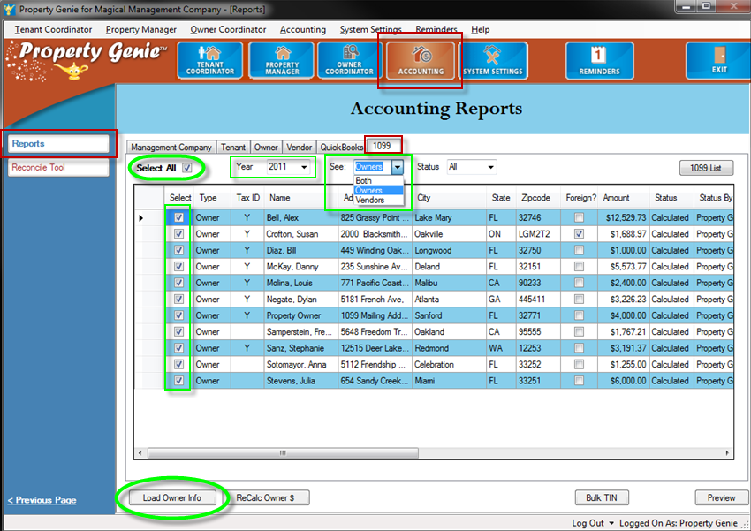
*This prompt gives you the option to update “only the selected owners”, or to simply “erase and reload all owners”. If this is the first time you are processing 1099’s then select Erase & Reload All Owners.
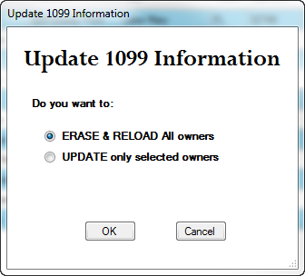
**Say OK if you ready to overwrite all of the information in the 1099 screen.
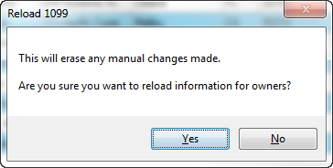
***If you recall in Step 2 we had you update all owners who provided a custom address for their 1099. For any owners who you did not fill in this field, Property Genie will use the owner’s mailing address after clicking the YES button.
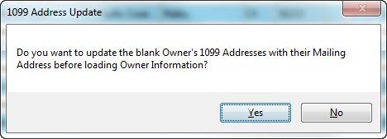
****When it prompts you to recalculate ALL Owners’ 1099 balances for (YEAR), say YES. This will run a query similar to the one used when generating the yearend report to calculate the owner’s income.
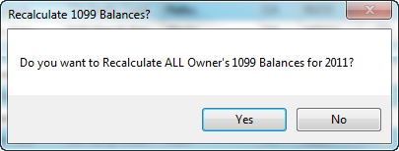
- Verify the amount of income from the owner’s yearend summary statement matches the amount of income listed in the owner’s 1099 amount. If the amount is different, then go through that owner’s statements to try and find the difference.
*A user can adjust the Amount Column by selecting the data in it and typing in a new amount. For users who started using Property Genie in the middle of the year and want to print one 1099, they will have to calculate the amounts manually and fill in the data.
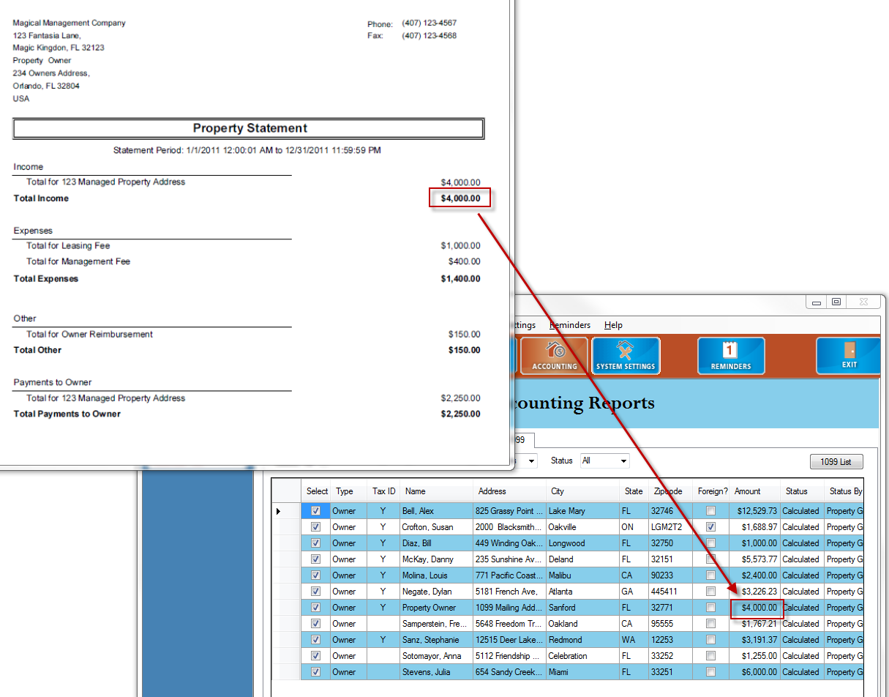

- Preview and Print the 1099s.
- After selecting all of the owners you wish to print a 1099 for, click the button labeled “Preview” in the lower right hand corner.
- This will open up the Report Viewer window with the data formatted to print on a standard 1099 form. (You can download and print these forms for free from the IRS, or go buy the templates pre-printed from nearly all office supply stores)
- Load your templates into your printer and make sure they are inserted the right way so the data prints in the boxes.
- Click the PRINT icon (printer logo), then select your printer and finish printing like you would any other document.
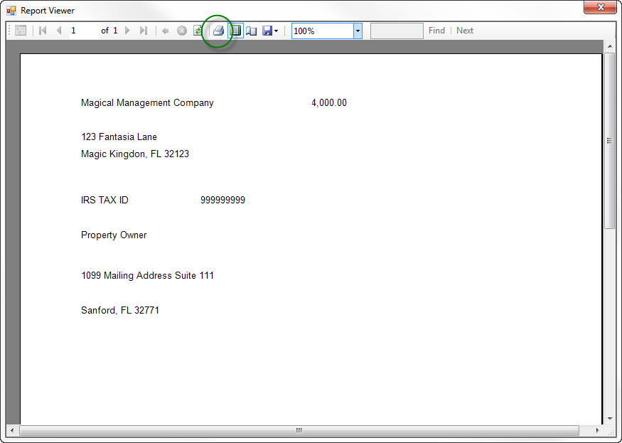
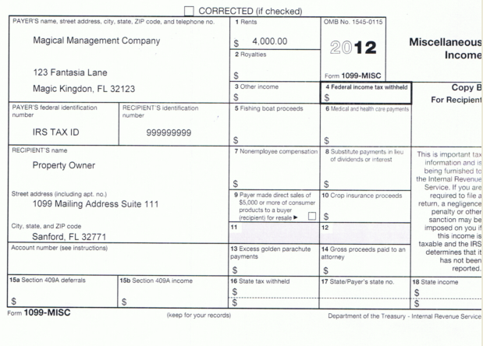

- Keep track of the documents you’ve printed by clicking the button in the top right hand corner of the page running the 1099 List report .

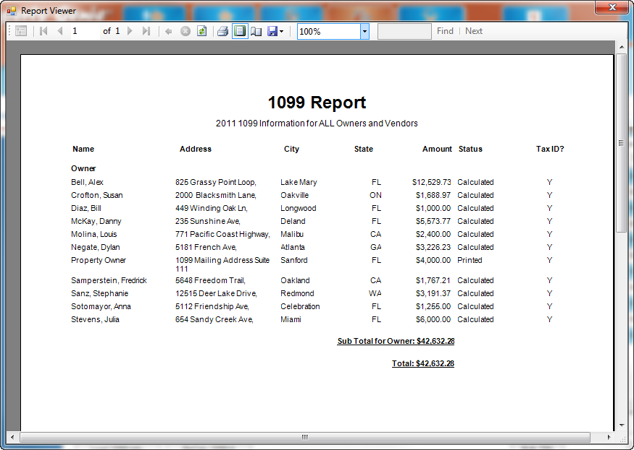

If the amounts do not appear correct on the 1099, be sure to review all of your charges. Make sure Owner income items are checked in the 1099 column:
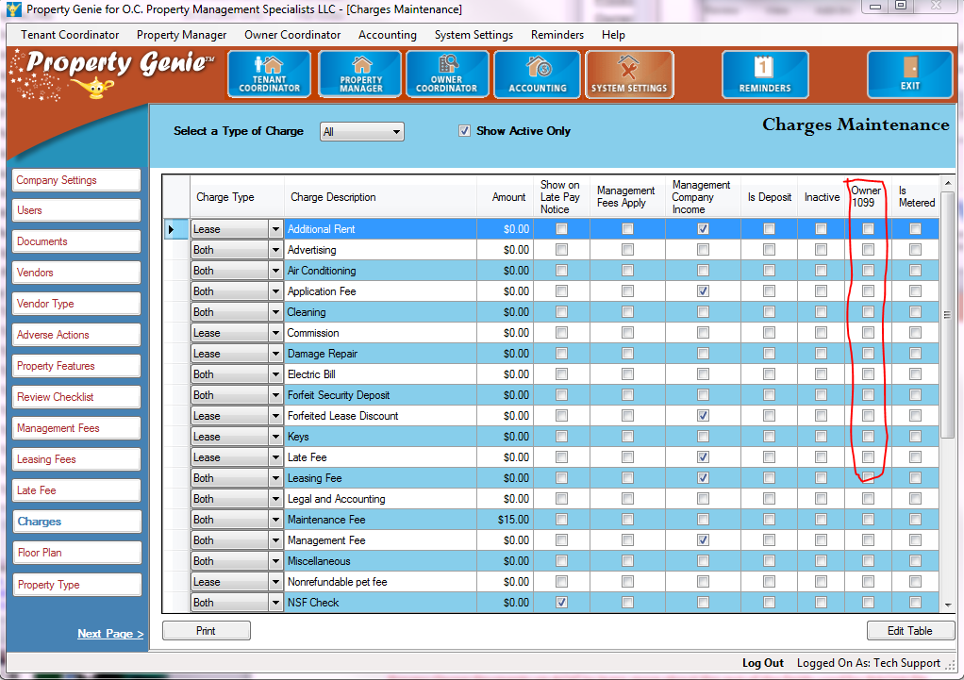

How to process 1099 reports as an eFile that is directly uploaded to the IRS website:
(REQUIRED if you have 250 or more properties)

Under Accounting, reports, select 1099 tab.
Load Owner Info > Loads just the Owner list and their 1099 mailing addresses

ReCalc Owner $ > Calculates the Owners 1099 amounts

Bulk TIN > Creates a file to upload to the IRS Bulk TIN verification system

Create eFile > Creates the eFile to upload to the IRS

Preview > shows the 1099s in Preview of the printed format

1099 List >
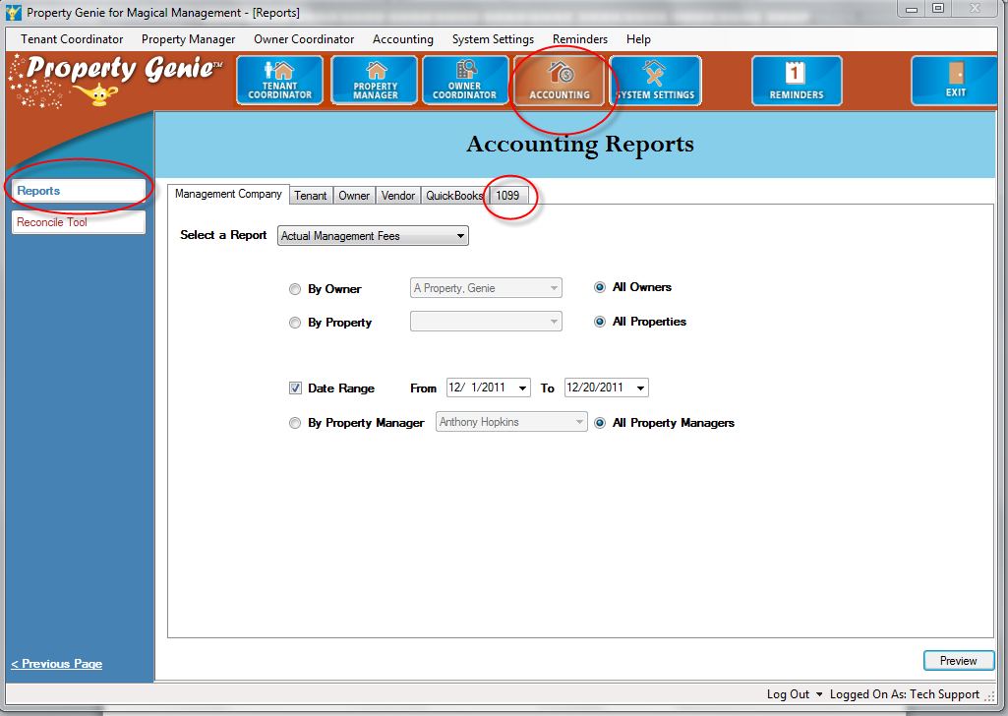

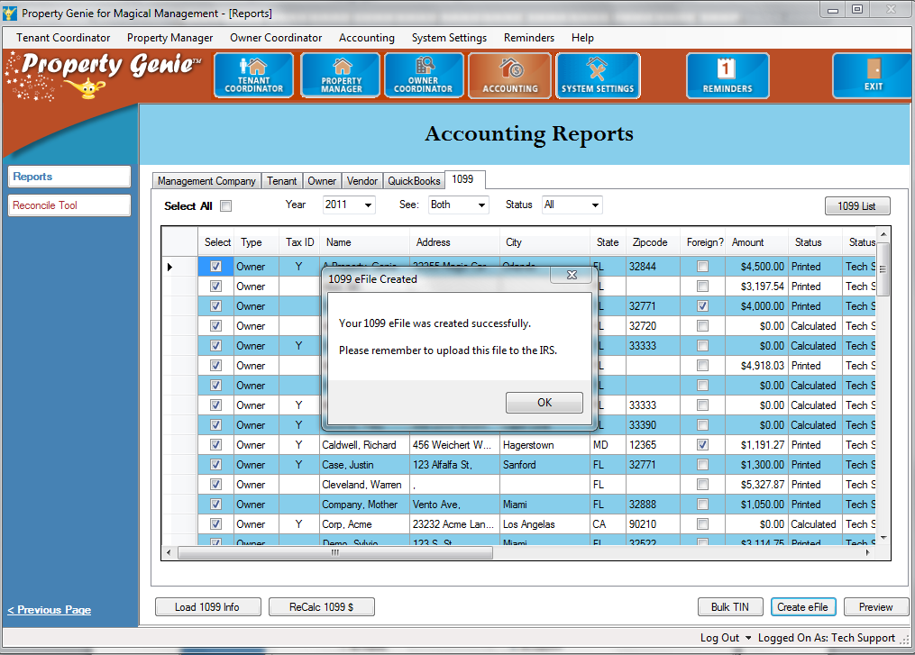

1099_111220_1536.txt
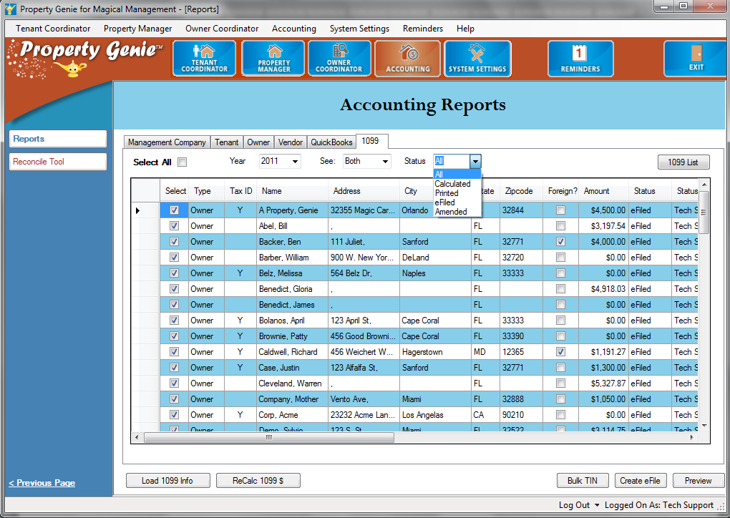

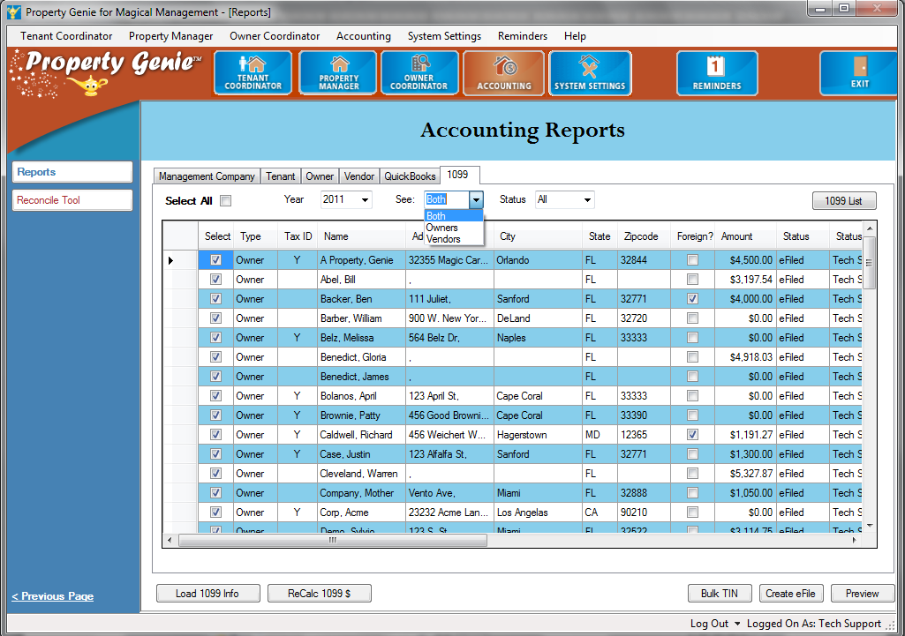
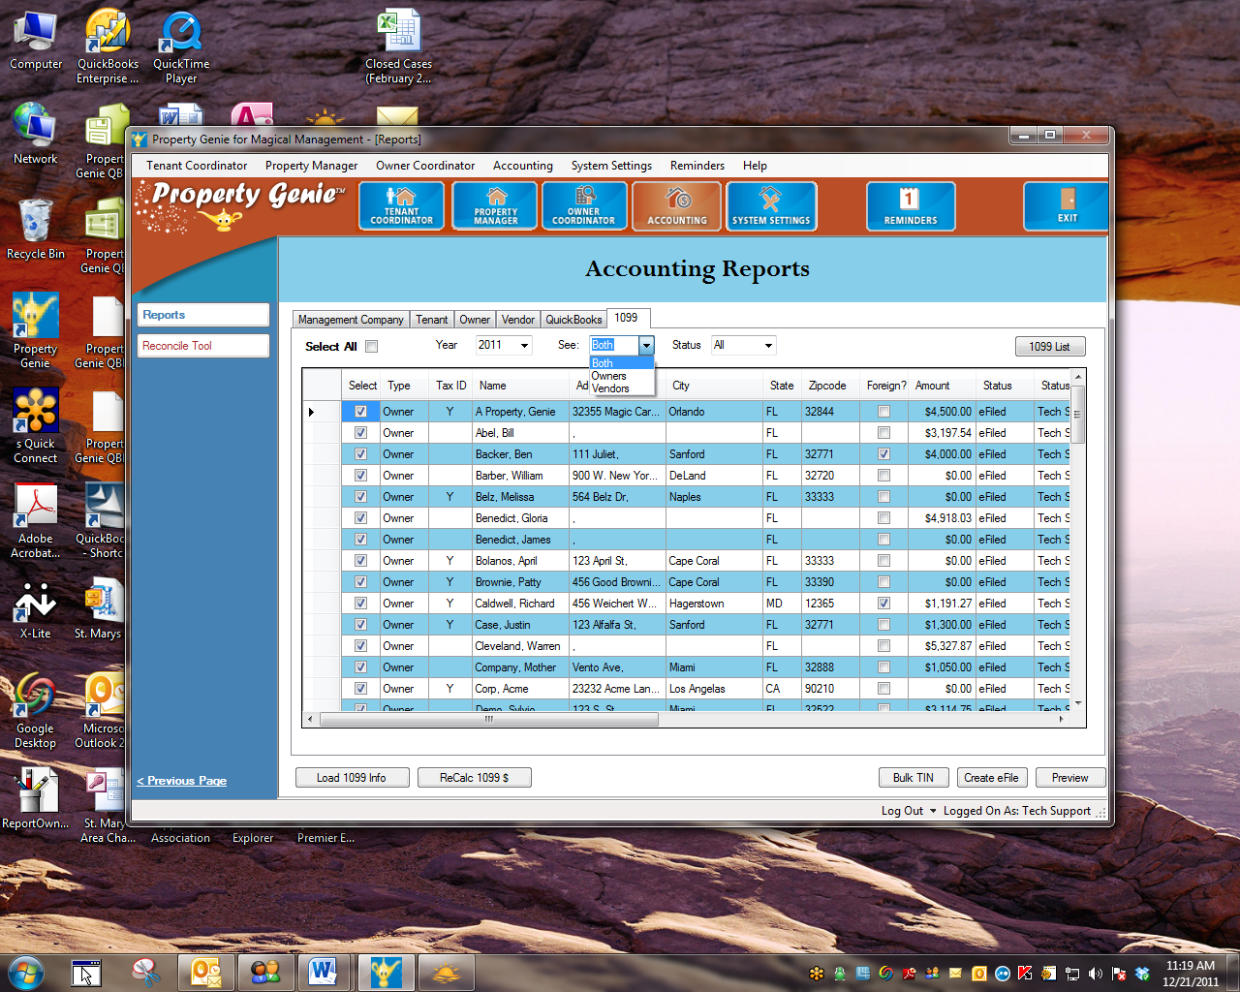

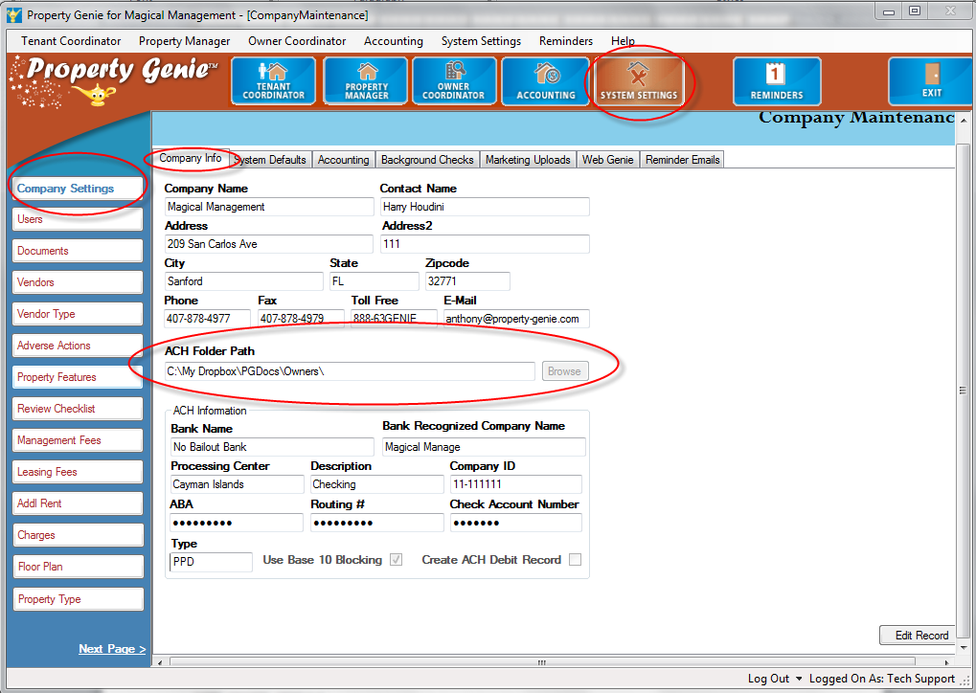

The file is created in Property Genie, but must be uploaded to the IRS via their website.

Once you have processed the Owner 1099’s, you can follow the steps above to create Vendor 1099’s, by selecting Vendors in Step 4, Item C.
The Vendor 1099 is based on the income date of the charge in Property Genie – that is, when the charge for that work order was paid. It is based on the completed date of the Work Order because often there is a lag time between the completion dates and when the Property Management Company receives payment for the Work Order and it is then paid.
In addition, the 1099 is a sum of the work orders that were performed AND the recurring checks that were issued to the vendor.
Based on the above information, you may want to consider using QuickBooks to prepare your Vendor 1099’s. However, if you choose to prepare them in Property Genie it is recommended that you run Vendor Reports in QuickBooks to verify the checks cut to the Vendor for the year to compare to the numbers in the Vendor 1099 in Property Genie.

