Billing Procedures for Property Genie
Procedure for Posting Rent
- Go to monthly Charges and post the rent charge.

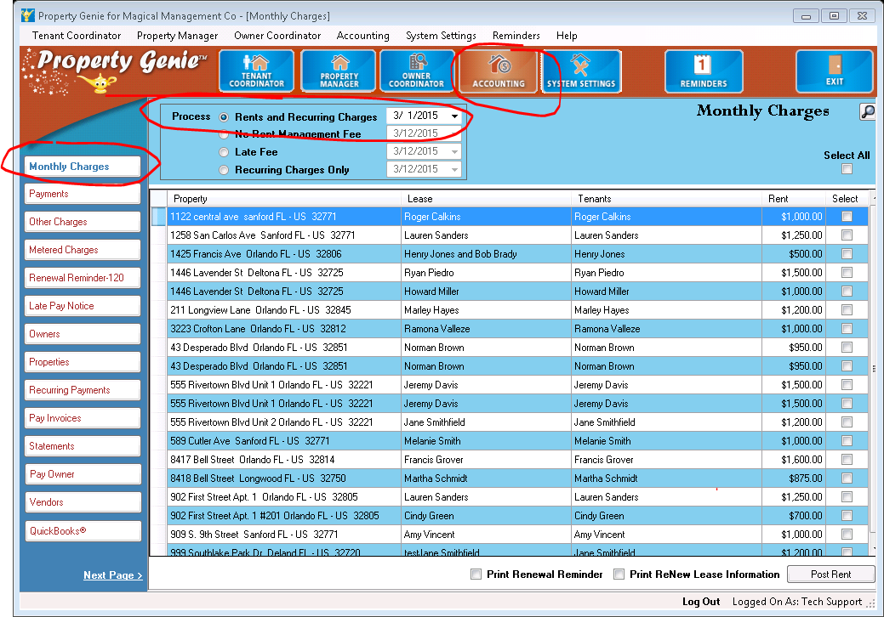

- Receive as they come in

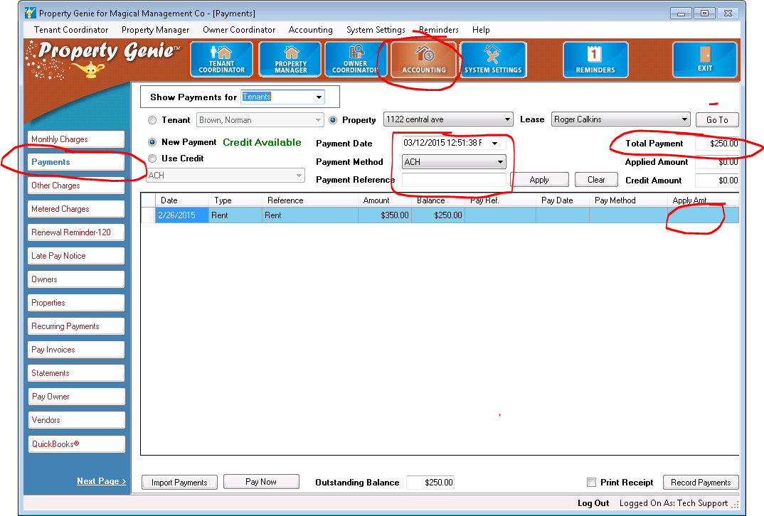

- Transfer to QB daily
Detail Transfer will show you each transaction

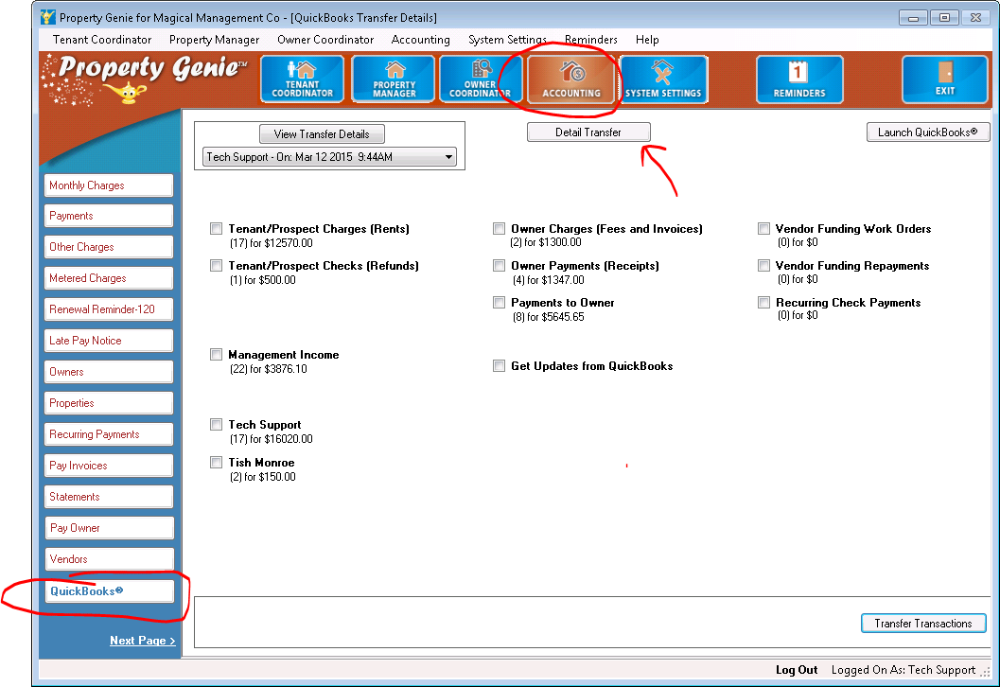

- Make appropriate deposits through QB.

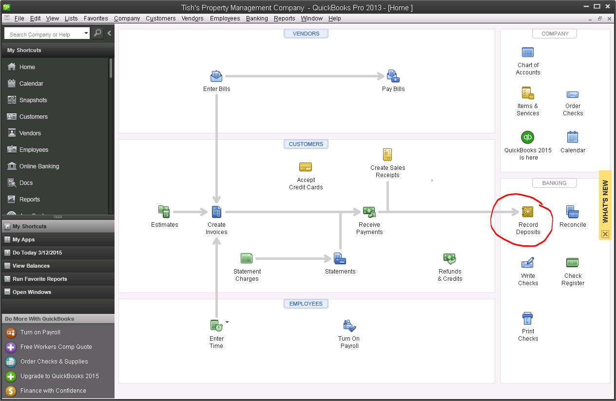

Procedure for paying the owner and bills in PG.
- Print out Owner Balances (Accounting/Reports/Owner/Owner Balances
- Review to determine if you are going to manually alter owner payments based on Work Order Estimates, are there any work orders you want to resolve or post charges for, invoices you need to post etc.

- When that is done, go to Pay Invoices, and click Process All Owners

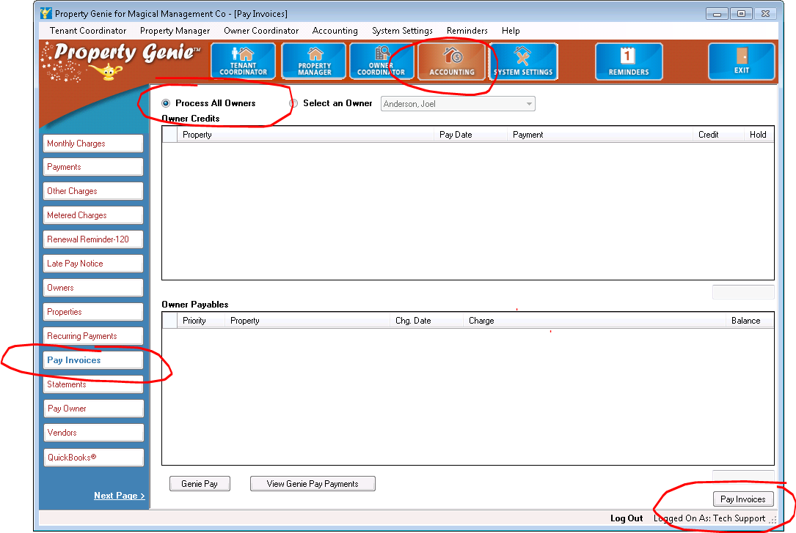

- Go to Recurring Payments and pay those.

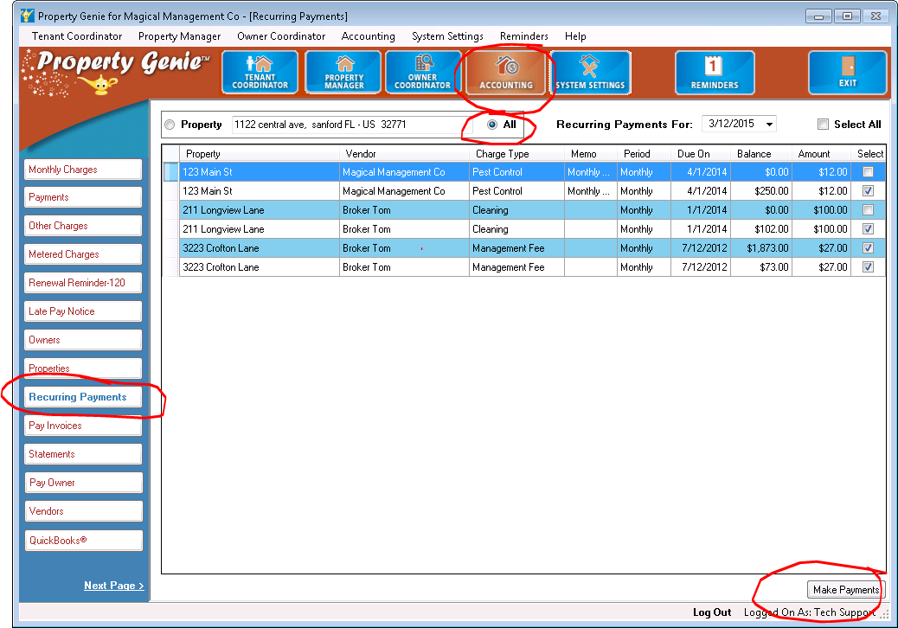

- NOW, pay owner.

NOTE: We recommend paying the ACH owners in one batch and then doing the owners who receive checks in a second batch.

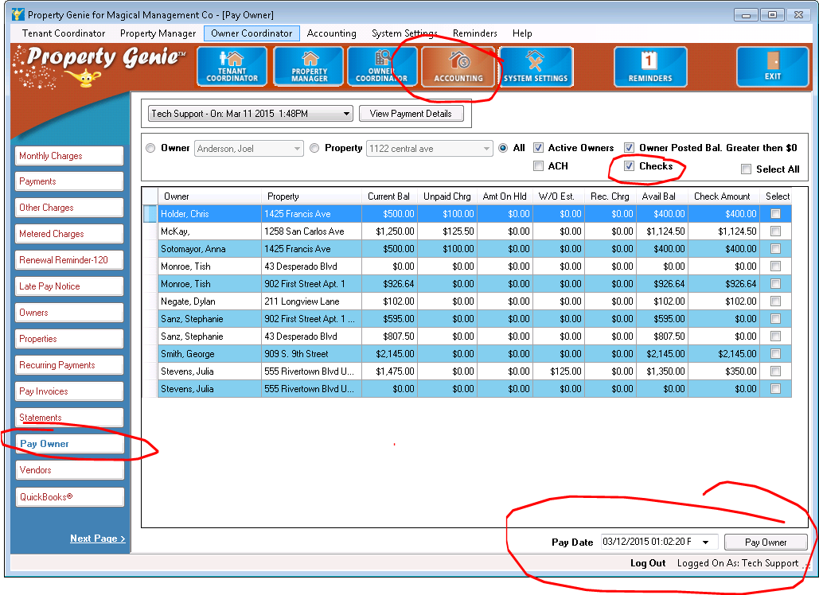

- Transfer transactions to QB. Always do the lease transactions first (rent,SD)
- Cut checks

NOTE: If PG is set up to Create Bills not Checks for owners and/or vendors then in QuickBooks you will go to Vendors/Pay Bills.

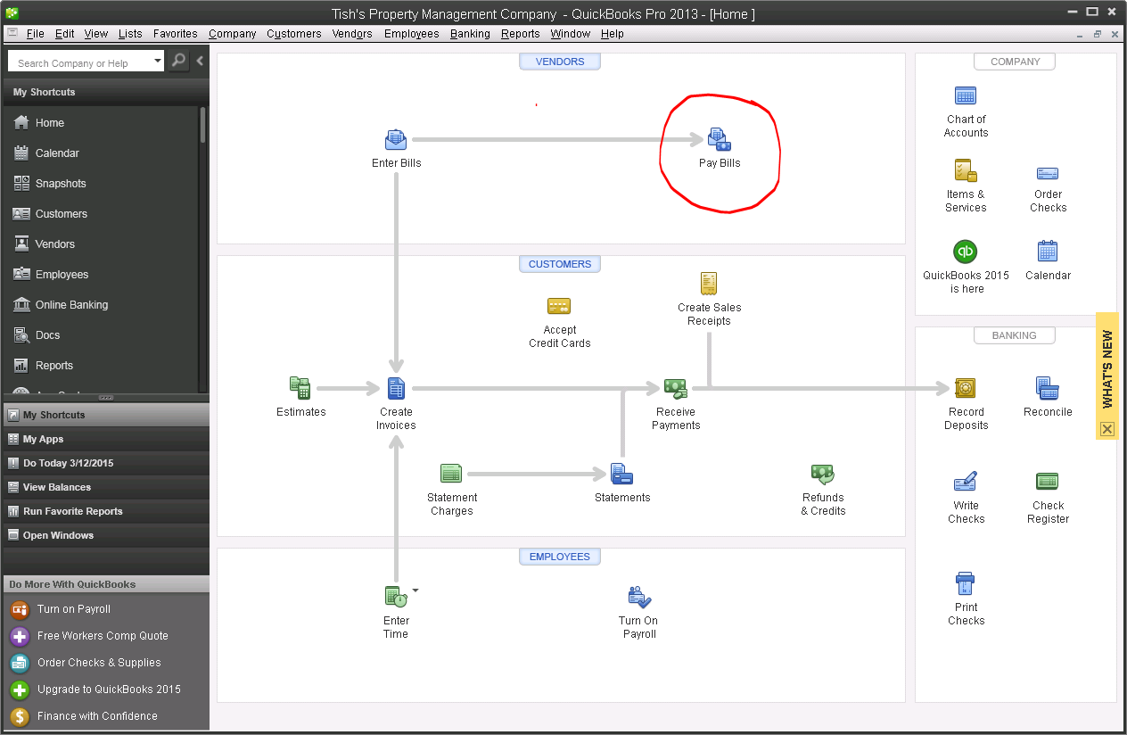

If PG is set up to create checks for owners and/or vendors then in QuickBooks you will go to Banking/Print Checks.

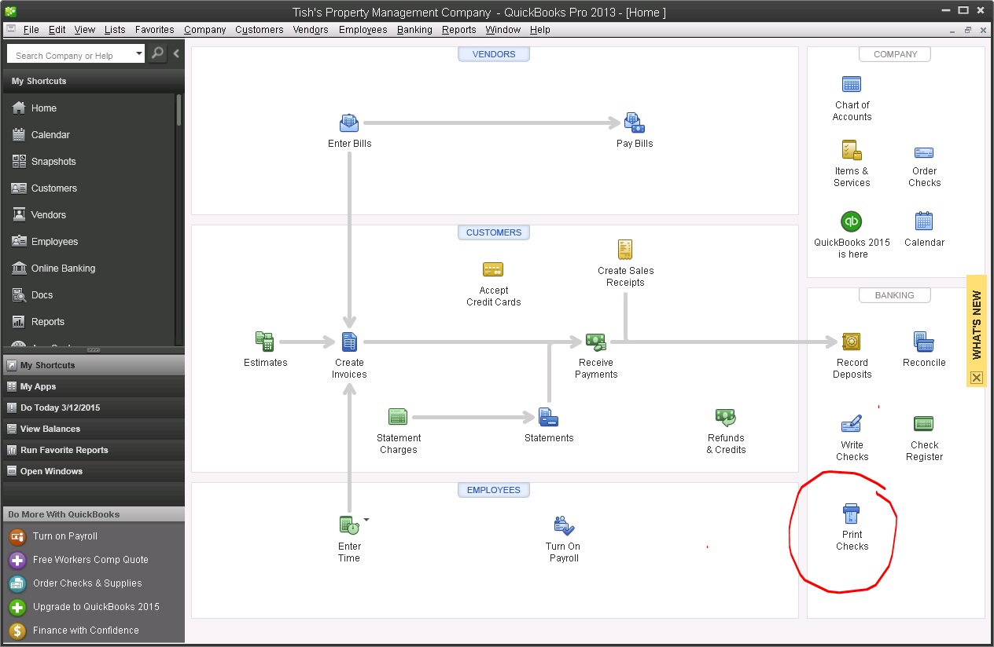

Procedures for month end balancing/reconciliation between PG & QB
- Clear the QuickBooks transfer screen by transferring all the transactions to QuickBooks.
- Print Checks in QuickBooks for those that need to be printed
- Review the Vendor – Pay Bills to clear any bills (Management Income, etc.) that need to get paid from QuickBooks
- Run an Owner Balance report [Accounting]-[Reports]-[Owner Tab]-[Owner Balances Report] with:
  - [All Owners]-[All Properties]-[All Property Status]-[All Property Managers]. The Posted Balance column total will provide you with your total Owner’s monies on hand.
  - [All Owners]-[All Properties]-[All Property Status]-[All Property Managers] AND [Posted Balance]-[Less Than]-[0]. This will show you owner’s that have negative balances due to bounced checks or forced paid invoices.
- Run a Property-Tenant Balance report [Accounting]-[Reports]-[Tenant Tab]-[Property Tenant Balance] Report with:
  - [All Owners]-[All Properties]-[All Lease Status]-[All Property Managers] AND [Credit Balance]-[Greater Than]-[0]. The Credit Balance column total will provide you with your total Tenant’s monies on hand.
- The balance in the QuickBooks Property Management checking account should equal Owner’s Monies (from #4) + Tenant’s Monies (from #5) plus any management income not yet taken.

ALONG WITH THE REPORTS LISTED ABOVE, YOU WILL ALSO WANT TO RUN THE FOLLOWING REPORTS AT MONTH END TO HAVE ON HAND IN THE EVENT OF AN AUDIT. THE REPORTS RUN AS OF THE CURRENT DATE, SO IT IS IMPORTANT THAT THEY BE RUN AT THE END OF EVERY MONTH.
- [Accounting]-[Reports]-[Tenant Tab]-[Security Deposits] Report (Choose ALL for Selection Criteria)
- [Accounting]-[Reports]-[Tenant Tab]-[Prospect Balance] Report (Choose ALL for Selection Criteria)
It is recommended that you run all of the reports and export them to pdf to save them as an electronic file.

